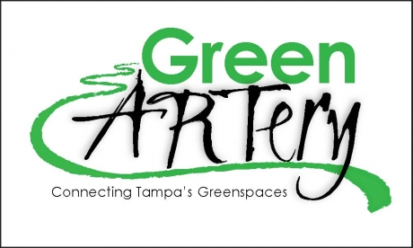
The Green ARTery
Board of Directors Mtg. Minutes
DATE: May 15, 2014

CALL TO ORDER
6:36 PM

QUORUM
Faye Miller, Myron Griffin, Rich Yates, Bill Hunter, Joseph Costa, Melinda Ray, Evan St. Ives, Mark …. (Riverside Heights), Juan Rivera (Palmetto Beach)

Motion to approve agenda: Evan / Second: Bill / All approved

NEIGHBORHOOD CONCERNS: Members present concerns to the Board [15 minutes allowed].
Items requiring action will be referred to committee or added to the agenda under New Business.
In attendance were Josh Bush, Southeast Seminole Heights, Juan Rivera, representative for Palmetto Beach, also Jim and Nancy

REPORTS OF OFFICERS
President: GA to be included in new trails brochure from MPO on next printing.
Already funded are the Green Spine, through downtown and South Tampa and the West River Greenway. Need to move GA up in the pecking order for funds.
Also need to look into Tiger Grants and how Green Artery may qualify.
WE should check in activities on the Atlanta Beltline for ideas for Tampa’s Green Artery.
Fowler has been approved for a 7 foot buffer for bike lanes.
Mail Chimp is up and running and we need to continue to add names
Heidi has been working on new website for Green Artery
Planting at Ulele’s has been rescheduled tom occur on either May 30th or June 1st.
Bylaws have been approved
Ryan Horstman resignation has been approved
Wes Miller has been nominated interim Treasurer and approved by the Board
A new bank account for the Green Artery will be set up to limit/eliminate fees.
Due to length of agenda Faye suggested a special meeting to address remainder of items
Meeting set for Monday, May 19 at 4PM

UNFINISHED BUSINESS

NEW BUSINESS
Meeting began with a presentation by Jean Duncan and Calvin Thornton focused on Walk-Bike Plan III followed by Karen Kress and Jim Shirle on bike safety.
Headlight of Jean Duncan’s talk was the Green Artery is officially a city project and $45000 from MPO has been earmarked for preliminary engineering and cost studies. We have also been charged to develop branding for the Green Artery.
Evan spoke about drafting a letter in support of St Paul’s church request for matching funding from a Grant. Motion to forward letter: Evan Second: Rich All in favor
Rogers Park is now part of OSHNA

LETTERS INCOMING

LETTERS OUTGOING

ACTION WITHOUT A FORMAL MEETING

UPCOMING MEETINGS

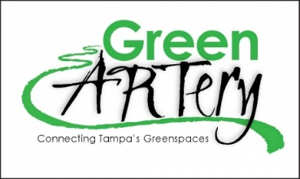
Executive Committee Minutes
Page 2

ANNOUNCEMENTS

ADJOURNMENT

Respectfully submitted
Melinda Rey, Secretary

