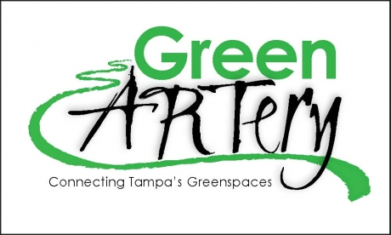
The Green ARTery
Board of Directors Minutes
DATE 08/21/2014

CALL TO ORDER
6:35pm
QUORUM
Rich Yates, Myron Griffin, Joe Costa, Melinda Ray, Vince Schwellenbach, Mark Smith, Evan St Ives, Michael Lynch, Heidi Bissel

NEIGHBORHOOD CONCERNS: Members present concerns to the Board [15 minutes allowed].
Items requiring action will be referred to committee or added to the agenda under New Business.

REPORTS OF OFFICERS

President:
- Rich Yate presiding
- Minutes approved with a motion by Evan
- $56.96 in the account
- Mini Grant for $2,500 with 22nd St project applied for
Committee Reports

Branding – Vince Schwellenbach
- 24 neighborhoods represented in the arteries of the tree logo
- The new logo has been endorsed by over 300 branding experts
- Vince presented digital mockups of the logo on business cards, letter head, tee shirts and other applications
- Kick start campaign with our new logo and tee shirts. Discussed variation of tee shirts for different groups
- Faye will take charge of who has document control
- Vince said his company will be willing to help offset some of the printing costs
- Can get tee shirts for around $2.00 each
- Brochure- purely conceptual right now. Need a generic brochure with talking points, our history and our mission; not to include specific details but to possibly include a conceptual map.
- Vince will share the URL to website. Need to add bi-laws and other links…site is about 60% complete. The site is adaptable for on different devices. Can incorporate GoPro
Built on an e-commerce platform so it functions as store front. New website will help to identify how the GA and the perimeter trail connect and will identify other GA projects.
- EC has voted to accept the new logo and website. Motion for the board of directors to accept the package by Mark Smith, Evan 2nd, motion passed.
- Vince has asked that we give positive and negative comments about the website and package

22nd Street Project – Mark Smith
- Mark Smith has reached out to an engineer to start a cost analysis
- Need to have a clear plan to present to the residents in each neighborhood and the benefits of the trail
- In 30 days Mark will have a plan of action to take to the neighborhood civic association meetings
- 22nd street project will run east to 22nd St and turn north so it’s not really directly behind any of the homes. They still need to be informed and involved in the project so they will take some “ownership” in this part of the trail. Evan suggested a separate meeting just for the 17 residents on Patterson. Tanja will research the benefits of the trail…Rich has drafted a letter already and will tweak it to include a meeting date/time. Mark made a motion to send the letter and set the meeting within the next 2 weeks to ask for input and concerns, second Joe Costa…all in favor, motion passed.
- Include a survey as part of the process.
- Parks and Recs are waiting for the final map
Membership –
- No report
Green Space and Art:
- Myron will start to photograph the Art along the existing trails and in the connecting parks
Communications:
- Meeting from 8/16/14 discussion for talking points should relate to all of the positive effects of the trail
- Joe will take on some of the research to show all of the positive effects of these types of projects
- Maybe redirect the MPO directions through positive responses to the trail
- USF has worked with the GA so maybe we could have some of the volunteer to help distribute information and knock on doors to get class credit
- Hope to have all of the talking points and facts by August 29th.
- Gopher video Florence is to edit down to a 3 minute video
- 2040 Plan people are voting on line for GA
- Petchacha need to wait for the next one in 6 months
Fundraising:
- Tanja needs the talking points and brochures to start conversations for fund raising
- Bike Map – need to reach out to local businesses to by ad space on the map. A membership fee gives you a discount at the businesses on the map.
- Rich asked Tanja to give us a budget for producing and printing the map as well as what is involved.
- Vince said he may be able to provide a list of the businesses and build the document with all of the company logos.
- The suggestion was made that we sell the map on the premise of “bikeable streets and trails in Tampa”.
- Need a list of established parks so we can get “Beautifaction” projects

UNFINISHED BUSINESS
New Business

OSHNA Yard sale on November 8th suggestion to sell GA items. $5 to get our name on the map and members can donate items as a fund raiser. Life Path Hospice will pick up all unsold items. Vince offer his home for the yard sale. Evan will be our point of contact.

LETTERS OUTGOING

No report
ACTION WITHOUT A FORMAL MEETING
Process Check:
- Team building exercise
- Evan pointed out that part of the meeting should have been committee meetings with reports in BOD meeting. Still running a little long in the meetings
- Motion by Myron that meeting adjourn at 8:00 or vote for an extension, Mark 2nd all in favor

UPCOMING MEETINGS
Executive Committee Meeting Sept. 11, 2014
Board of Directors Meeting Sept 19, 2014

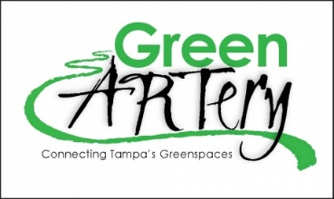
Board of Directors/General Membership Minutes
Page 2

ANNOUNCEMENTS

ADJOURNMENT 8:22pm

The meeting was adjourned with a motion by Joe, Rich 2nd all in favor

Respectfully submitted
Melinda Rey, Secretary

